# NETWORKING & SYSTEM ADMINISTRATION LAB

**Name: LIBIYA JOSE**

**Roll No: 14**

**Batch: MCA B Date: 04-04-2022**

**Experiment No.: 6**

# Aim

Familiarization of basic Linux commands.

# Procedure

1. **read**

This command is used to read from a file descriptor.

**Syntax:-** $ read name

# Output:-

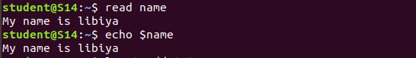

1. **locate**

It is used to find the files by name.

**Syntax:-** $ locate a.txt

# Output:-

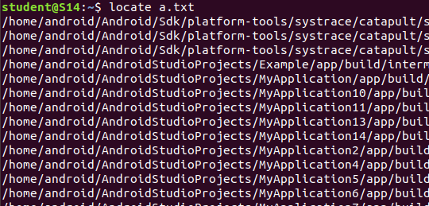

1. **locate -i**

**-**i,-ignore-case :Ignore case distribuions when matching patterns.

**Syntax:-** $ locate –I b2.txt

# Output:-

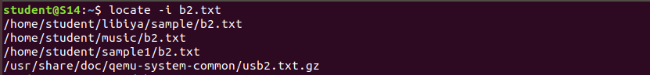

1. **find**

This find command is used to search and locate the list of files and directories.

**Syntax:-** $ find a.txt

**Output:-**

C:\Users\ACER\Downloads\FIND.png

# grep

This grep command will let you search through all the text in a given files.

**Syntax:-** $ cat > cls.txt

# Output:-

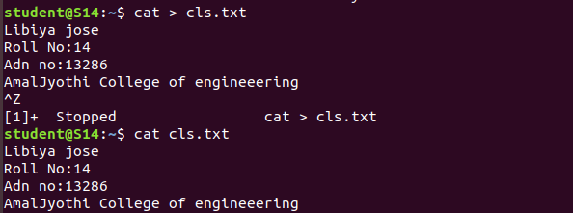

1. **grep –i**

-i :- ignores, case for matching.

**Syntax:-** $ grep –i Roll cls.txt

# Output:-

C:\Users\ACER\Pictures\lab 6.3.png

1. **grep –v**

-v:- This prints out all the lines that do not matches the pattern.

**Syntax:-** $ grep –v Roll cls.txt

# Output:-

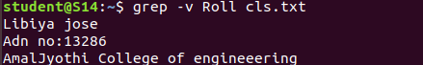

1. **grep –A1**

-A1:- Prints searched line and n lines after the result.

**Syntax:-** $ grep –A1 Roll cls.txt

# Output:-

C:\Users\ACER\Pictures\lab 6.3.png

1. **grep –B1**

-B n:- Prints searched line and n line before the result.

**Syntax:-** $ cat marvel1.txt

# Output:-

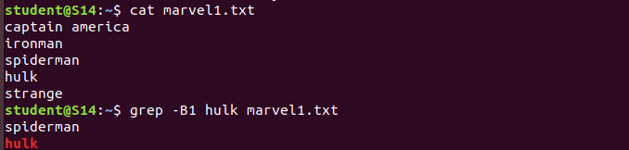

1. **grep –C1**

-C1 n:- Prints searched line and n lines after before the result.

**Syntax:-** $ grep –c1 spiderman marvel1.txt

# Output:-

C:\Users\ACER\Pictures\lab 6.4.png

1. **df**

Command gives the estimation of the total amont of the disk memory space used by the input files and stored files in memmory directions.

**Syntax:-** $ df marvel1.txt

# Output:-

C:\Users\ACER\Pictures\lab 6.4.png

1. **df -m**

It is used to display inmegabytes.

**Syntax:-** $ df –m marvel1.txt

# Output:-

C:\Users\ACER\Pictures\lab 6.4.png

1. **du**

du command short for disk usage , used to estimate file space usage.

**Syntax:-** $ du marvel1.txt

# Output:-

# C:\Users\ACER\Pictures\lab 6.4.png

1. **wc**

If it is used to find out no.of lines, word count, byte and characters count in the files specified in the file arguments.

By default it displays for columnar output.

**Syntax:-** $ wc marvel1.txt

# Output:-

# 

# C:\Users\ACER\Downloads\wc.png

1. **wc -c**

This option display count of bytes present in file.

**Syntax:-** $ wc-c marvel1.txt

# Output:-

# 

# C:\Users\ACER\Pictures\lab 6.4.png

1. **wc -w**

This option points the no.of words present in a file .

**Syntax:-** $ wc-w marvel1.txt

# Output:-

C:\Users\ACER\Pictures\lab 6.4.png

1. **wc -l**

This option points the no.of lines present in a file .

**Syntax:-** $ wc-l marvel1.txt

# Output:-

C:\Users\ACER\Pictures\lab 6.4.png

1. **wc -m**

If displays count of characters from a file .

**Syntax:-** $ wc-m marvel1.txt

# Output:-

C:\Users\ACER\Pictures\lab 6.4.png